Display all the sports activities available in your city for coming weekend

|  |  |  |  |
| --- | --- | --- | --- |
|  | Prepared By | Reviewed By | Approved By |
| Name | Kayath Nagarani | Chandrasekar, Venkataraman |  |
| Role | Intern | Batch Trainer |  |

Table of Contents

1. Introduction…………………………………………………………………..…3

               1.1 Intended Audience……………………………………………….......3

               1.2 Project Scope…………………………...……………………………3

2. Overall Description…………………………………………….……………….3

               2.1 Operating Environment……………………...……………………....3

3. Requirements……………………………………………………………...…….4

              3.1 Functional Requirements……………………....…………………….4

              3.1.1 location ………………………………............................................4

              3.1.2 sports activity……..………………………………………...……...5

  3.1.3 google log-in……………………………………...………………..6

**1. Introduction**

Townscript is an online website which is used to search for events, interests and activities happens in our city. Here we are testing functionality of the website i.e., to search for all the fitness and wellbeing (Sports) activities that happens in this weekend and extract the names of the activities with dates.

**1.1 Intended Audience**

Business Unit (BU) SME

Academy coach

Technical Trainer

**1.2 Project Scope**

This document defines at a functional level the business activities that are encompassed by the system and the rules that apply to them. It also encompasses some of the key high and low level technical requirements of the system.

It draws heavily on both proposed Framework and Business Rules and the Technical Architecture documents. The scope of the detailed analysis project phase specifies that this document will include.

· Classification of requirements according to their functional areas.

· A description of each process in the system, including their inputs, outputs, and data transformation rules.

**2. Overall Description**

**2.1 Operating Environment**

Windows operating system

Web application

**3. Requirements**

This part of the requirements document serves to present the "Townscript to search for events, interests and activities " of the application and also we need to extract all the events that happen in this weekend from “Fitness and wellbeing(sports)” activities.

**3.1 Functional Requirements**

**3.1.1 Req0001**

**Req0001a-** After opening the website user clicks on My Booking

**Req0001b**- The user selects the location dropdown

**Req0001c-** click on the location “Chennai”.

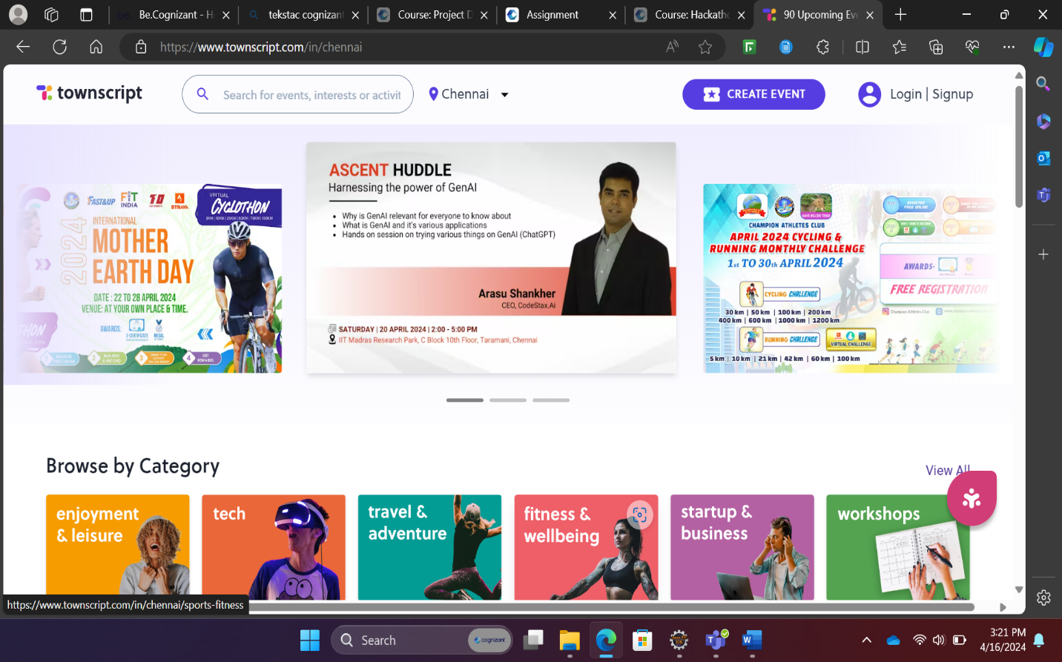

**3.1.2 Req0002**

**Req0002a-** The user clicks on “Fitness and Well being ” from the browser by category

**Req0002b**- User selects the date dropdown and selects “Weekend”

**Req0002c-** User changes the list of events from grid view to list view

**Req0002d**- User captures the list of events with date and also captures the popular cities

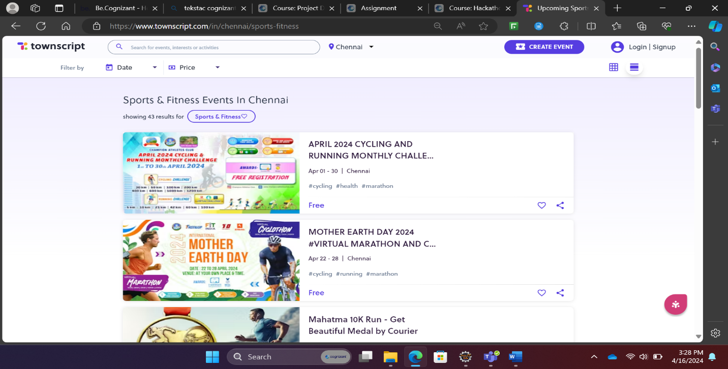

**3.1.3 Req0003**

**Req0003a-** The user clicks on Registration

**Req0003b**- User clicks on continue with Google

**Req0003c-** User enters invalid email id and captures the error message



